Using My Jmol Unplugged
– providing internet-free browser-based access to the best of 3D molecular visualizations

My Jmol Unplugged is a customizable collection of web pages and associated data files. With it, you can use a rich variety of 3D molecular resources in a classroom without access to the internet. There are two general ways to use this data collection:
1) as Jmol Unplugged. Just open one of the top-level web pages and use it as is. Some of these web pages are full copies of Jmol-based web apps that are on the web. Others are relatively blank starting points that you will need to load models from using the web or drag-drop files from one of the models directories into the Jmol window of these pages.
2) as My Jmol Unplugged. One of the most interesting aspect of My Jmol Unplugged is that you can customize it to load models that you modify or design yourself, or you get from other webpages that use JSmol. To do this, all you do is save a model from the page as a “PNG+JMOL” file. This file appears to be an image to the file system (so you can view the directory as a set of images), but included in that image is a full set of data that can reproduce the “Jmol state” exactly as it was when you saved the file.
Saving a PNG+JMOL file. Saving a PNG+JMOL file is very easy, provided the web site you are at has implemented the Jmol popup menu, which most web sites do. The process is as follows:
1. Get the model just the way you want it to appear when you reload it.
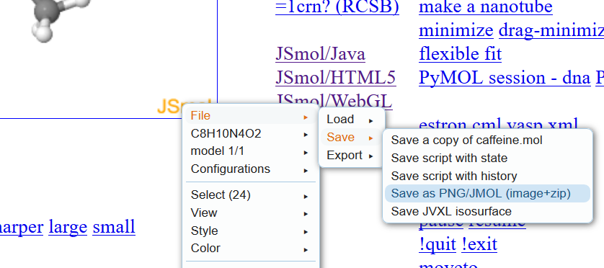
2. Click on the JSmol logo in the bottom right corner of the application. The file will be saved in your browser’s download folder.
3. From that folder, you can move it anywhere you want.

Restoring a PNG+JMOL file. To restore the model, just open _unplugged.htm in the directory you found these instructions, or navigate to any site using Jmol. Then, from the directory containing the downloaded model, drag-drop the file into that page. A neat trick is that you can drag files on your file system to icons in your system tray to move as you drag. Don’t release the model until you are hovering over the JSmol application.
Occasionally there are models that do not restore properly. That may be due to a JSmol version problem. If that is the case, feel free to send the file to hansonr@stolaf.edu for checking.

